Project Request
Amend the Zoning Map to Rezone 63.4 acres from T2 zoning to TC Zoning (T1 and T4 zoning) located at 4339 Columbia Pike.

UPDATE SINCE AUGUST TSPC
Subsequent to the August TSPC meeting, the applicant produced a conceptual plan in an effort to incorporate feedback from the TSPC into the overall development. At the September BOMA meeting, the applicant also provided a list in the meeting of self-imposed conditions placed on the rezoning application. The concept plan and self-imposed conditions are included in the submittal for this item. The BOMA expressed that the Planning Commission should review these changes to this rezoning request and provide a recommendation based on this new information. It should be noted that, under the Tennessee Code, these conditions must be unilateral. Therefore, the TSPC (and the BOMA) must review the rezoning application, with self-imposed conditions as presented.

Updated Concept Plan
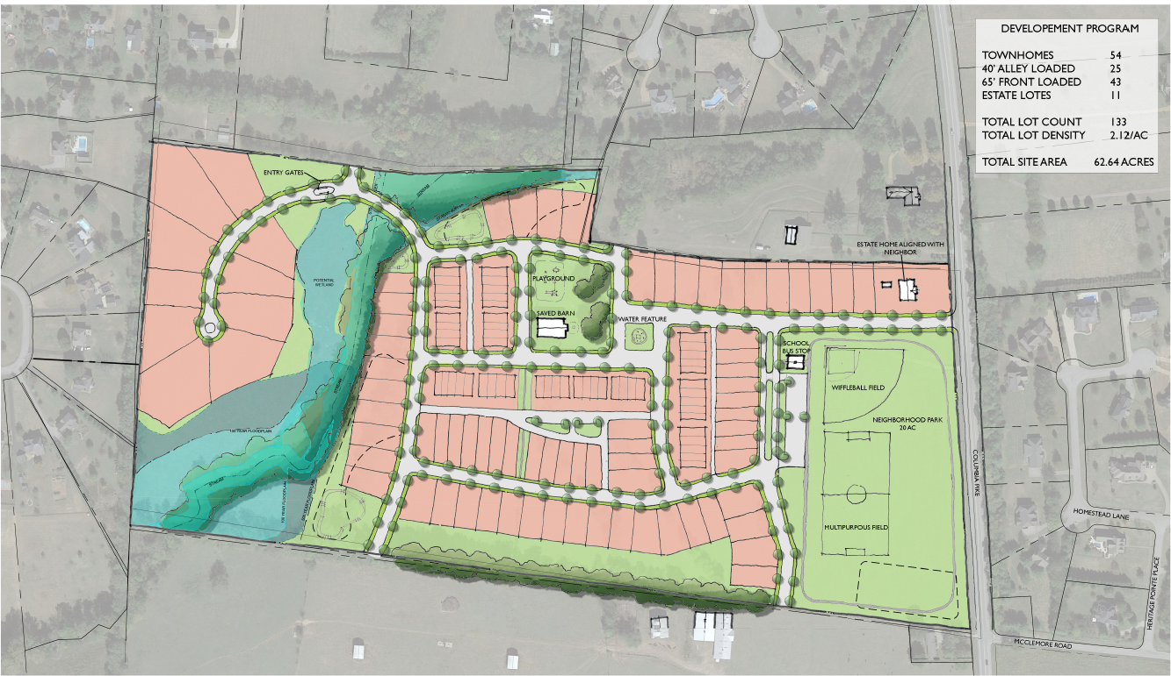

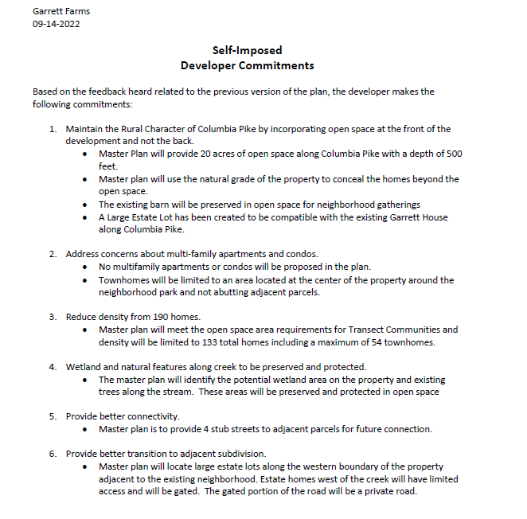

Staff Recommendation
Staff recommends the Planning Commission provide a favorable recommendation onto the BOMA, with the applicant’s self-imposed conditions.

Project History:
In January 2022, the applicant withdrew a D3 rezoning from the January BOMA agenda and revised the request for a D2 zoning. The request was unfavorably recommended onto BOMA by the TSPC and denied by the BOMA. Subsequently, the BOMA made a motion to not consider any upzonings until after the completion of the All Aboard Comprehensive Planning process. The Town Attorney has determined that this rezoning request should be considered by the Planning Commission while the Town separately proceeds with a formal ordinance placing a moratorium on rezonings.

This request was heard by the TSPC in August, where an unfavorable recommendation was provided, since the request did not preserve the rural characteristics of the community while accommodating for future growth in an orderly manner. At the September BOMA Meeting, the BOMA expressed a desire for the TSPC to reconsider the request after the applicant provided a conceptual design and a set of self-imposed conditions. Therefore, this item is provided for reconsideration on the September TSPC Agenda.

Project Description
A request from Tennessee Valley Homes, Inc to rezone 63.4 acres along Highway 31 (Columbia Pike) for a proposed residential development with TC (Transect Community) zoning that will establish T1 and T4 zoning on this property.

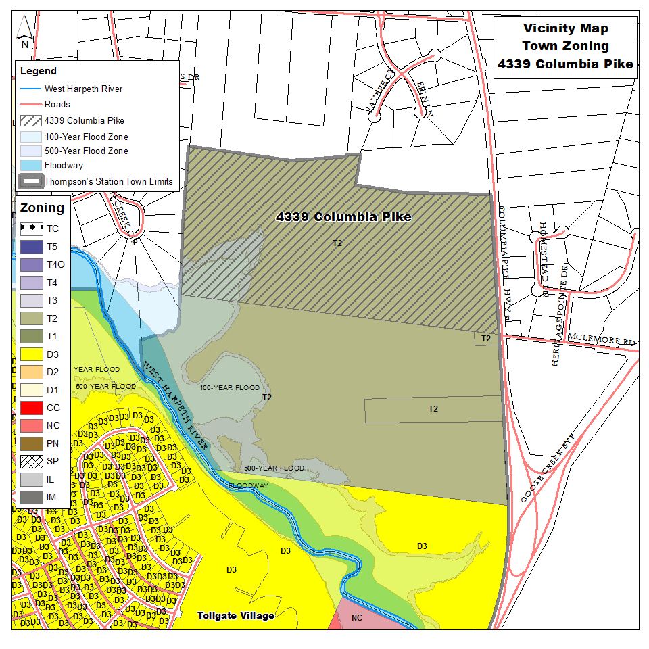

Purpose of a Rezoning Request
Changing the zoning of a particular parcel will allow the owner of the parcel to develop or use their property based on the corresponding use table within the Land Development Ordinance. The Planning Commission has jurisdiction to evaluate the request based on the General Plan and make a formal recommendation to the Board of Mayor and Aldermen. The recommendation can be favorable or unfavorable based upon relevant considerations.

Site Context
The subject site is located within the G1 – Controlled Growth sector of the General Plan and is zoned as T2, which is a rural district that permits the development of single family residential with a density of one unit per 8 acres. The site is bounded by agricultural and residential to the north, residential land to the east, and residential and agricultural land to the south.

Analysis
The subject property is located north along the Columbia Pike corridor. The site is predominantly vacant with a barn/outbuilding on site. The subject property is located within the G1 – Controlled Growth Sector, which allows for “rural character, including hamlets and villages.” In Staff’s observation, the surrounding, existing developments and location of this property do not exactly fit a rural context, with residential subdivisions currently existing to the west, north, and east of this site. Additionally, this site is in proximity to Tollgate Village, which is mixed zoned D3 and NC. The proposed development, if designed according to the LDO could fit within the village community type.

This site is located along an arterial state highway near the intersection with Goose Creek Bypass. Therefore, the transportation network adjacent to this site is generally conducive to residential zoning.

The General Plan does provide limited guidance on new residential development within the Town. In Land Use Element Goal 1, it does recommend preservation of the rural characteristics of the community, while “accommodating for future growth in an orderly and sustainable manner.” The Planning Commission should review this Goal and determine if this project, as presented, meets the intent of our current General Plan.

The Sector Plan does designate this area as a G1- Controlled Growth Sector, which calls for a rural development policy; however, there are existing D3 and D2 zones within existing G1- Controlled Growth sectors, including the newly approved Parsons Valley subdivision, The Villages Subdivision, Country Haven, and Allenwood. This fact somewhat clouds guidance provided by the Sector Plan for future land use policy.

These inconsistencies and inadequate guiding policy for this type of request highlights the need to revise both the General Plan and the Sector Plan as part of the All Aboard comprehensive planning process; however, though those needs are not a consideration in this rezoning request. The Planning Commission should determine if an extension of the development pattern established by Tollgate Village and allowed in parts of other G1 Sectors should extend along Columbia Pike and whether the same would preserve rural characteristics of the community, while accommodating for future growth in an orderly and sustainable manner.

As part of a preliminary plat for any future development, a Traffic Impact Study will be required to evaluate specific transportation related improvements. Additionally, future submittals will include additional information related to tree preservation, floodplain, open space, lot layout, and site design. The applicant has provided an illustrative concept plan to accompany the rezoning request.

The Planning Commission should consider the information presented and determine if the request submitted satisfies the guidance provided by the General Plan and the Sector Plan. Additionally, the Planning Commission should consider the statement of impacts provided by the applicant and whether or not it provides sufficient information related to the impact on the Town’s orderly development, transportation infrastructure, sewer infrastructure, and community facilities.

If the Planning Commission finds that this development has provided sufficient information related to the statement of impacts and meets the guidance of the General Plan and Sector Plan, a recommendation of approval to the BOMA is appropriate. If the Planning Commission finds that this development does not meet the guidance of the General Plan and Sector Plan or that the statement of impacts is not sufficient, the Planning Commission should provide an unfavorable recommendation to BOMA with specific findings as to that recommendation.

