Project Request
Temporary Use Permit request for a Christmas Tree Lot 4801 Columbia Pike (Heritage Elementary School campus) by Boy Scout Troop 16.

Project Description
Christian and Wren Fraser and Boy Scout Troop 16 request approval of a Temporary Use Permit (TUP) for a Christmas Tree Lot from November 5 – December 20, 2022. This Christmas Tree Lot is in the same location as previous years.

Analysis

Temporary Use Permit
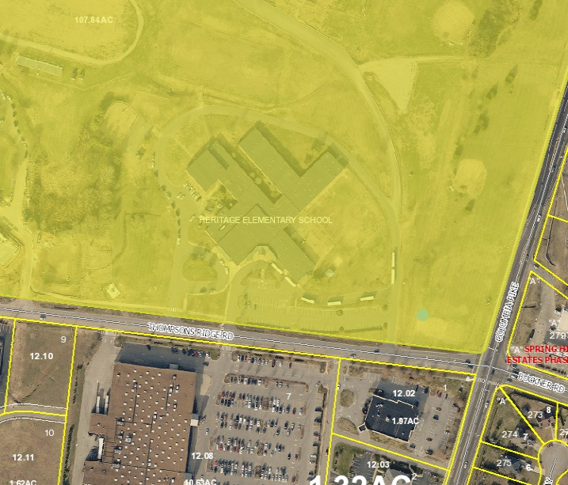
Per Table 5.2, Approval Authority, the Planning Commission is vested with the authority to approve a TUP. This is a change in procedure brought about by a legal determination by the Town Attorney in relation to a separate TUP request. Once the Town Attorney provided this legal opinion, Staff redirected all pending and future requests to the Planning Commission.

A TUP is a discretionary approval by the Planning Commission. The LDO does not provide review criteria, so the Planning Commission will need to review the request and make a finding of facts related to the appropriateness of this request. The Planning Commission may approve, approve-in-part, or deny the request. Review of the site access, traffic control, impact to the property and surrounding properties, impact to the natural environment, noise, hours of business, safety of the patrons and participants, sufficient facilities for restrooms, and parking are some of the elements of this request the Planning Commission may take into consideration during the findings of facts related to this TUP.

PC Review
Planning Commission should review the information provided by the application and determine if a Temporary Use Permit is appropriate.

If the Planning Commission approves the TUP, Staff recommends the following conditions:
1. This Permit only remains valid for the Christmas Tree Lot to occur, as described in the attached proposal, Tuesdays beginning November 5 – December 20, 2022.
2. If any aspect of the elements noted in the attached proposal are not strictly adhered to, Town Staff is to be vested with the authority to cancel this permit at any time.
3. All standards and regulations of the LDO and other Town regulations apply.

Attachments
Applicant submittals

