Development Agreement for
Parsons Valley Subdivision (Phase 1 & 2)

THIS SUBDIVISION DEVELOPMENT AGREEMENT (hereinafter the “Agreement”), is made effective this the13th day of September, 2022 (hereinafter the “Effective Date”), by and between Beazer Homes, LLC with principal offices located at 501 Corporate Centre Drive, Suite 180 , Franklin , TN 37067, (hereinafter the “Developer(s)”); and the Town of Thompson’s Station, Tennessee, a municipality duly incorporated, organized, and existing under the laws of the State of Tennessee (hereinafter the “Town”).
I. PURPOSE OF THE AGREEMENT

1. The Beazer Homes, LLC is the Developer of Phases 1 and 2 of the real property located on 4738 Columbia Pike and identified as Williamson County tax map 153, parcel 23. The property contains approximately 118.83 acres +/-, (hereinafter the “Project Site”). The Project Site is currently zoned D3 (High Intensity Residential).

2. The Developer desires to improve and develop Phases 1 & 2 of the total phases of (6) of the Project Site or a portion of the Project Site into a development to be known as Parsons Valley, (hereinafter the “Project”), under the regulations of the Town current on the Effective Date of the approval of Preliminary Plat.

3. This Agreement is subject to Town approval of the Final Project Documents for the Project, which includes but is not limited to plat approvals (with conditions as determined by the Town), detailed construction plans and specifications, in accordance with the Town’s charter, ordinances, rules, regulations, and policies (hereinafter “Town Regulations”) as well as State law, and applicable sureties. The Developer and Town agree that all Final Project Documents shall be attached to this Agreement as Collective Exhibit “A” and incorporated herein by reference after their approvals by the Town.

4. The Developer agrees to install necessary and required public improvements (hereinafter “Public Improvements”) as shown on the Final Project Documents including, but not limited to: water lines, fire hydrants, sanitary sewer and sanitary sewer lines, grading, streets, curbs, gutters, sidewalks, street name signs, traffic control devices, street lights and underground electrical power and gas utilities, as well as all other improvements designated herein, at no cost to the Town.

5. The Developer agrees to install and maintain private improvements and amenities, as applicable and as shown on the Final Project Documents, including, but not limited to: private streets and alleys, fences, walls, lakes, common open space, site lighting, storm water management systems, retention and/or detention basins, storm sewers, inlets etc., landscaping and related irrigation systems, relative to said Project, none of which shall be accepted for maintenance by the Town.

9. The Town agrees to approve the Project subject to the Developer’s compliance with applicable Town Regulations and the conditions set forth herein in Exhibit “B”, and the Town agrees to provide customary services to the Project in accordance with the Town’s Regulations after Final Acceptance, as defined herein.

II. GENERAL CONDITIONS

1. Affidavit of Payment - Prior to Final Acceptance, the Developer shall deliver to the Town an affidavit certifying that all subcontractors and material suppliers furnishing labor and/or material for the Public Improvements required under this Agreement have been paid in full. The Developer shall also provide a written release of any and all liens and/or security instruments, and of the right to claim liens, from all subcontractors and material suppliers furnishing labor or materials for the Public Improvements.

2. Approval of the Final Project Documents - The Final Project Documents, which are attached hereto as Collective Exhibit “A” and incorporated herein by reference, shall be stamped as approved by the Town, provided that the same are in compliance with Town Regulations. All construction relating to the Project shall be subject to inspection and approval by the Town until Final Acceptance and shall be subject to any conditions set forth on Exhibit “B”.

3. Construction Activity Periods - The Developer will not carry on or permit construction activity under this Agreement earlier than 7:00 a.m. and not later than 6:00 p.m., Monday through Saturday, and no construction activity shall occur on Sundays or holidays. Construction hours shall be enforced by the Town at the Developer’s expense.

4. Construction Standards - The Developer shall construct the Project as shown on the approved Final Project Documents in accordance with requirements of the Town Regulations.

5. Demolition - The Developer agrees to secure all required permits from the necessary governmental entities, including the Town, for the demolition of structures on the Project Site. The Developer further agrees that it will haul all scrap, buildings, materials, debris, rubbish and other degradable materials to an authorized landfill and shall not bury such materials within the Project Site.

6. Deposition of materials in street prohibited - All construction material, including, without limitation, mud, silt, dirt, and gravel, shall be kept off existing streets at all times. In the event such mud, silt, dirt, gravel or other construction material is washed, blown, or carried into an existing street, the Developer shall take immediate steps to remove such materials. If the Developer does not remove such materials after notification by the Town, and the Town deems it necessary to clean the affected streets, the Developer agrees to reimburse the Town for all such cleaning expenses, plus an additional twenty-five percent (25%) for administrative expenses related to the same.

7. Development Agreement Modification Fees - The Developer agrees to pay the fee for any modifications to this Agreement in accordance with the Town schedule of fees applicable to such a modification and that are current at the time of submittal of a written request for a modification by the Developer, including, but not limited to, time extensions, addendums, or amendments.

8. Developer’s Default - The Developer agrees that should it default in performing any of its obligations under this Agreement, and it becomes necessary to engage an attorney to file necessary legal action to enforce provisions of this Agreement or sue for any sums of money due and owing or liability arising incidental to the Agreement, Developer shall pay to the Town all reasonable attorney's fees and expenses of litigation stemming from said default.

9. Developer’s Liability - It is expressly understood and agreed that the Town is not and could not be expected to oversee, supervise and/or direct the implementation of all construction and improvements contemplated in this Agreement. The Town is not responsible for the design of the Project or any way the suitability of the property for Project.

a. The Town Planner or his or her designee may make periodic inspections and has the right to enforce the provisions of this Agreement and Town Regulations.
b. The Developer now has and shall retain the responsibility to properly anticipate, survey, design and construct the Project improvements and give full assurance that same shall not adversely affect the flow of surface water from or upon any property.
c. In providing technical assistance, plan and design review, the Town does not and shall not relieve the Developer from liability, and the Town does not accept any liability from the Developer.
d. The Developer will provide its own Project Engineer and may not rely on the review of Town staff or its engineers with respect to the Project.
e. Neither observations by the Town, nor inspections, tests or approvals by others shall relieve the Developer from its obligation to perform work in accordance with Town Regulations and the terms of this Agreement.

10. Duration of Obligations - The obligations of the Developer hereunder shall run with the Project Site until the Developer’s obligations have been fully met, as determined by the Town in its sole and absolute discretion. Any party taking title to the Project Site, or any part thereof, prior to Final Acceptance shall take said real property subject to such obligations. The Developer shall not be released of its obligations under this agreement without the express, written approval of the Town.

11. Easements - The Developer agrees that it will grant all necessary easements and rights-of-way, as determined by the Town, across its property necessary to satisfy the requirements of this Agreement without expense to the Town and will waive any claim for damages from the Town. Any off-site easements and/or right-of-way owned by others but required for the project must be obtained by Developer, recorded prior to approval of the Agreement, and noted on the Final Project Documents.

12. Emergency Response - In emergencies affecting the safety or protection of persons or the work or property at the Project Site or adjacent thereto, the Developer, without special instruction or authorization from the Town, is obligated to act to prevent threatened or eminent damage, injury, or loss.

13. Indemnity - Developer shall indemnify and hold the Town harmless and agrees to defend the Town and the Town employees, agents, and assigns against any and all claims that may or happen to arise out of or result from the Developer’s performance or lack of performance under this Agreement, whether such claims arise out of the actions or inactions of the Developer, any subcontractor of the Developer, or anyone directly or indirectly employed by, or otherwise directly or indirectly involved with the Project at the direction of the Developer or subcontractor of the Developer. This indemnity and hold harmless agreement includes, without limitation, all tort claims, both intentional and otherwise, and all claims based upon any right of recovery for property damage, personal injuries, death, damages caused by downstream deposits, sediment or debris from drainage, damages resulting from the Developer changing the volume or velocity of water leaving the Developer’s property and entering upon the property of others, storm water that is allegedly impounded on another property and claims under any statutes, Federal or state, relative to water, drainage and/or wetlands, and reasonable attorney’s fees and costs incurred by the Town in defending itself or its employees, agents, or assigns as a result of the aforesaid causes and damages and/or enforcing this Agreement.

14. Notice of Violation - The Town Planner and/or Town Engineer, or his or her designee, may issue a Notice of Violation (NOV) when violations of Town, State, or Federal laws and/or regulations are observed.

a. If the Developer has not corrected the violation identified in the NOV, then the Developer agrees that the Town acting through the Town Planner and/or Town Engineer may perform the necessary work to eliminate the violation and document all expenses incurred in performing the work. Developer shall reimburse the Town for all such expenses plus an additional reasonable administrative cost not to exceed twenty-five percent (25%).
b. Prior to releasing any Security hereunder and as herein defined, all expenses incurred by the Town relative to the foregoing shall be paid in full by the Developer.
c. The Town may issue a Stop Work Order (SWO) if the Developer does not promptly correct any deficiency or violation identified in the NOV in the reasonable time determined by the Town. The Developer agrees to comply with any SWO issued by the Town. If Developer fails to comply with a SWO, the Developer shall be responsible for all costs the Town incurs, including reasonable attorneys’ fees, in seeking a restraining order or other injunctive relief or legal action to remedy any deficiency or violation.

15. Ownership of Public Improvements - The Developer shall be responsible for all Public Improvements until Final Acceptance by the Town. Developer shall have no claim, direct or implied, in the title or ownership of the Public Improvements after Final Acceptance. The Town shall have no obligation to maintain any Public Improvements unless and until Final Acceptance of the Public Improvement(s).

16. Permit Availability - A copy of all required permits and Final Project Documents must be kept on the Project Site at all times. If a NPDES Storm Water Construction Permit is required by TDEC, or any other permit required by any governmental entity, a copy of the Notice of Intent and the Notice of Coverage, or equivalent documents, shall be provided to the Town Engineer prior to commencement of construction for the Project.

17. Relocation of Existing Improvements - The Developer shall be responsible for the cost and liability of any relocation, modification, and/or removal of utilities, streets, sidewalks, drainage and other improvements made necessary by the development of the Project, both on and off site.

18. Right of Entry - The Developer agrees that the Town shall have the right, but not the duty, to enter the Project Site and make emergency repairs to any public improvements when the health and safety of the public requires it, as determined by the Town in its sole and absolute discretion. The Developer will reimburse the Town for the costs incurred by the Town in making said repairs, plus an additional reasonable fee for administrative costs not to exceed twenty-five percent (25%).

19. Safety - The Developer shall maintain barricades, fences, guards, and flagmen as reasonably necessary to ensure the safety of all persons at or near the Project Site at all reasonable and necessary times.

20. Stop Work Orders - The Town Planner and/or Town Engineer may issue Stop Work Orders (SWO) to remedy and enforce the provisions of this Agreement.

21. Termination of Agreement – This Agreement may be terminated by the Town if the Developer fails to comply fully with the terms and conditions of this Development Agreement.

a. The Town will give the Developer sixty (60) days written notice of the intent of the Town to terminate the Development Agreement, stating the reasons for termination, and giving the Developer a reasonable time to correct any failures in compliance, as determined by the Town.
b. If after receiving a Notice of Termination of the Development Agreement by the Town, the Developer corrects the non-compliance within the time specified in the Notice of Termination, the Development Agreement shall remain in full force and effect.
c. Failure by the Developer to correct the non-compliance will result in termination of the Development Agreement and collection of the Security by the Town.

If the Town terminates the Agreement, the Developer shall cease all work on the Project except as necessary to ensure the safety of all persons. The Developer (or a subsequent Developer) may apply to the Town for approval of a new Development Agreement, which approval shall not be withheld provided that all violations of this Agreement have been remedied.
22. Transfers of Project Ownership - Until all obligations of the Developer under this Agreement have been fully met and satisfied, the Developer agrees that neither the Project Site nor any portion thereof will be transferred to another party without first providing the Town with a fifteen (15) calendar day written notice of when the proposed transfer is to occur and the identity of the proposed transferee, along with the appropriate contact information for the proposed transferee, including address and telephone number of the proposed transferee.
a. If it is the proposed transferee’s intention to develop the Project Site or any portion thereof in accordance with this Agreement, the Developer agrees to furnish the Town with an assumption agreement, or equivalent as determined by the Town, by which the transferee agrees to perform the obligations required under this Agreement that are applicable to the property to be acquired by the proposed transferee.
b. Unless otherwise agreed to by the Town, the Developer will not be released from any of its obligations hereunder by such transfer and the Developer and the transferee both shall be jointly and severally liable to the Town for all obligations hereunder that are applicable to the property transferred. The proposed transferee will be required to furnish new Performance Security and Maintenance Security acceptable to the Town, as applicable and determined by the Town.
c. If it is not the proposed transferee’s intention to develop the Project Site or any portion thereof in accordance with this Agreement, the transferee must satisfy all applicable requirements of the Town, as determined by the Town, including payment of all outstanding fees, and must receive Town approval, in writing, to void this Agreement.
d. The Developer agrees that if it transfers said property without providing the notice of transfer and assumption agreement, or equivalent, as required herein, it will be in breach of this Agreement and the Town may require that all work be stopped relative to the Project and may require payment of the Performance and Maintenance Security to assure the completion of the Project, as determined by the Town in its sole and absolute discretion.

23. Underground Utilities - All electrical utilities shall be installed underground unless the requirement is expressly waived by the Planning Commission.

24. Building Permits – The Developer understands and agrees that, if the Developer applies for a building permit from the Town, the building permit shall be subject to all Town Regulations, as well as applicable State and Federal laws and regulations, in existence at the time the building permit is applied for and obtained.

25. Soil Dedication and Mapping. – The Developer understands and agrees that the Developer shall dedicate one and one-half (1 and ½) times the amount of soils the Town requires for effluent wastewater disposal as determined by the number of taps to be allocated per the Final Plat. The dedication must occur at the time of approval of the Final Plat. Prior to dedication, the Developer must present the Town with an extra high intensity soil map, per Tennessee Department of Environment and Conservation standards and requirements, of the soils contemplated for dedication. All soils must meet the needs of the Town for effluent wastewater disposal, including but not limited to use and area. In the event the Developer cannot dedicate the required amount of soils as determined herein, in whole or in part, the Developer must pay a fee in lieu of dedication as to said soils in an amount equal to one hundred percent (100%) of the value of said soils, as determined by the Town, at the time of approval of the Final Plat. Said fee shall be remitted to the Town’s wastewater fund.

III. REQUIRED IMPROVEMENTS

The Developer agrees to pay the full cost of all the improvements listed below if applicable to the Project.

1. Water System - The Developer agrees to pay the cost of a State of Tennessee approved potable water system, including, without limitation: water mains, fire hydrants, valves, service lines, and accessories, located within the Project, and water mains, fire hydrants, valves, service lines, and accessories, located outside the Project but required to serve the Project. The Developer acknowledges that the Town does not provide water service and will not accept any water system infrastructure. The Developer agrees to bear the cost of all engineering, inspection, and laboratory costs incurred by Developer incidental to the water service system in or to the Project.

2. Sanitary Sewer System - The Developer agrees to pay the cost of a State of Tennessee approved sanitary sewer system as required by Town Regulations with necessary sewer mains, manholes, pump stations, force mains and service laterals in the Project, along with all necessary sewer mains, manholes, pump stations, force mains, and service laterals outside the Project but required to provide sanitary sewer service to the Project. The Original Developer is approved for 353 single family homes and 88,250 gallons per day per an approved and executed Sewer Reservation Agreement, which has been revised by an Assignment and Assumption Agreement entered into by the Parties, which allocates the respective capacity rights and reservations pursuant to the Sewer Reservation Agreement The Developer agrees to bear the cost of all engineering, inspection, and laboratory testing costs incurred by the Developer incidental to the sewer system in or to the Project, and, if the Town Engineer or his or her designee deems it necessary, to have additional work of such nature performed as directed without cost to the Town.

3. Streets - The Developer agrees to dedicate and improve and/or construct, at no cost to the Town, all public and/or private streets, including but not limited to: curbs, gutters, and sidewalks, located within or required by this Project to comply with Town Regulations in accordance with the Final Project Documents.

a. In some circumstances, the Town may require the payment of an in-lieu of construction fee as an alternate to the construction of the required improvements by the Developer. The amount of any in-lieu construction fee will be one hundred and twenty-five percent (125%) of the estimated construction cost of the improvements, as determined by the Town in its sole and absolute discretion.
b. The Developer shall furnish and install base asphalt and a final wearing surface asphalt course on all streets, public and private, in accordance with the Town Regulations and the Final Project Documents. The Developer shall make all necessary adjustments to manholes, valve boxes, and other appurtenances as required to meet finished surface grade and to repair any areas designated by the Town, as required prior to the installation of the final surface asphalt.
c. The Developer agrees to install permanent street signposts and markers at all street intersections in the Project and to install traffic control devices, signage, and striping relative to and as required for the Project. All traffic control devices, signage, and striping shall be installed as per the latest edition of the Manual on Uniform Traffic Control Devices (MUTCD) and approved by the Town Engineer.
d. The Developer agrees to pay the cost of all engineering, inspection, and laboratory costs incurred by the Developer incidental to the construction of street(s) to be constructed or improved pursuant to this Agreement, including, but not limited to: material and density testing, and, if the Town Planner or his or her designee deems it necessary, to have additional work of such nature performed as directed without cost to the Town.

4. Streetlights - The Developer agrees to pay the cost of installation of Street Lighting along all public roadways improved as part of the Project, with said Street Lighting determined by Town Regulations and Final Project Documents.

5. Power Distribution Poles – The Developer agrees to pay the full cost difference between steel electric power distribution poles and the cost of wood electric power distribution poles for the Project frontage. If the Project frontage is along both sides of the public road, the Developer agrees to pay the full cost difference between steel electric power distribution poles and the cost of wood electric power distribution poles for the Project. If the Project is only along one side of the public road, the Developer agrees to pay one-half the cost of the difference between steel electric power distribution poles and the cost of wood electric power distribution poles for the Project frontage.

6. Gas and Electric Service - The Developer shall install underground electric and natural gas service to the Project in accordance with Town Regulations in effect at the time of such installation.

7. Stormwater Management System - The Developer agrees that all storm water management systems and related facilities, including, without limitation: permanent post-construction storm water runoff management best management practices, ditch paving, bank protection, and fencing adjacent to open ditches, made necessary by the development of the Project are to be constructed and maintained by the Developer.

8. Stormwater Pollution Prevention Plan - The Developer agrees that it will prepare, implement, and maintain a Stormwater Pollution Prevention Plan for the Project in accordance with all Town, State, or Federal regulations, and as approved in the Final Project Documents.

9. Best Management Practices - The Developer agrees that it will provide all necessary best management practices (BMPs) for erosion and sediment control. BMPs to control erosion and sediment during construction, include, but are not limited to, temporary vegetation, construction exit, inlet protection, and silt fence.

a. All freshly excavated and embankment areas not covered with satisfactory vegetation shall be fertilized, mulched, seeded and/or sodded, or otherwise protected as required by the Town Engineer to prevent erosion.
b. In the event the Town Engineer determines that necessary erosion and sediment control is not being provided by the Developer, the Town Engineer may issue a Notice of Violation (NOV) to the Developer.

10. Engineer’s Certification - The Developer shall provide the written opinion of a professional engineer, currently licensed to practice in Tennessee, attesting that the entire watershed where the Project Site is located has been reviewed, and that upon full development at the greatest allowable use density under existing zoning of all land within that watershed, the proposed development of the Project will not increase, alter, or affect the flow of surface runoff water, nor contribute to same, so as to damage, flood, or adversely affect any downstream property.

11. Stream Buffers - The Developer agrees to provide stream buffers along all regulated watercourses in accordance with Town Regulations and the TDEC General Construction Permit.

12. Changes and Substitutions - Should the Developer determine that changes or substitutions to the approved Final Project Documents may be necessary or desirable, the Developer shall notify the Town Engineer, in writing, requesting approval of the desired changes or substitutions, explaining the necessity or desirability of the proposed changes or substitutions. The request by the Developer must be accompanied by sufficient documentation, including drawings, calculations, specifications, or other materials necessary for the Town to evaluate the request. No changes are to be made in the field until express, written permission is granted by the Town Engineer.

IV. PROJECT SCHEDULE

1. Approved Final Project Documents – Prior to the recording of the Final Plat, the Developer shall provide to the Town electronic copies (PDF scans) of the Approved Final Project Documents (Collective Exhibit A) along with a signed acknowledgment that the documents submitted are incorporated into this Agreement by reference.

2. Demolition Permits - If demolition of any improvement on the Project Site is anticipated, a demolition permit from the Town must be obtained by the Developer.

3. Certificate of Insurance - Prior to the recording of the Final Plat, the Developer will furnish to the Town a Certificate of Insurance evidencing the required coverage and listing the Town as additional insured. The furnishing of the aforesaid insurance shall not relieve the Developer of its obligation to indemnify and hold harmless the Town in accordance with the provisions of this Agreement.

4. Surety - The Developer must pay all fees, furnish all required Sureties, as determined by the Town, prior to the recording of the Final Plat.

5. Commencement of Construction - The Developer agrees to commence construction within twenty-four (24) calendar months from the Effective Date. The failure of the Developer to commence Construction within twenty-four (24) months of the Effective Date will be considered an expiration of the Agreement, and a new agreement shall and must be approved before any Construction may begin.

6. Project Duration – It is anticipated that the Developer shall substantially complete the Project on a timely schedule and in an expeditious manner, with the date of Substantial Completion to be not later than 60 months from when the Developer commences construction of the Project.

7. Request for Extension - The Developer agrees that, if due to unforeseen circumstances it is unable to Substantially Complete all work included in this Agreement on or before the Substantial Completion Date specified above, it will submit a written request for extension of the Substantial Completion Date to the Town at least sixty (60) days prior to the specified date, stating the reason for its failure to complete the work as agreed, and a revised Substantial Completion Date. The Town will not unreasonably withhold approval of extensions of time where the Developer has complied with the requirements of notice to the Town and provided any required additional Security.

8. Breach of Agreement for Time Extension - The Developer agrees that its failure to follow the extension of time procedure provided herein shall constitute a breach of this Agreement, and the Town may take legal action, in its discretion, as described herein and as allowed by Town Regulations and applicable law.

9. Withholding or Withdrawal of Service - The Developer agrees that, should it fail to complete any part of the work outlined in this Agreement in a good and workmanlike manner, the Town shall reserve the right to withhold and/or withdraw all building permits and/or water and sewer service within the Project until all items of this Agreement have been fulfilled by the Developer, or as an alternative draw upon the Security to complete the work.

V. PROJECT CLOSEOUT

1. As-Built Drawings - Prior to Final Acceptance, the Developer shall submit as-built plans / as-built drawings of the improvements installed as part of the Project, including but not limited to: the potable water system, the sanitary sewer system, the drainage/detention/stormwater management system, landscaping, irrigations system, photometric plan, and streets including curbs and gutters and sidewalks, signed and sealed by a Design Professional, confirming that the installed improvements are in compliance with Town Regulations and the approved Final Project Documents.

2. Letter of Completeness – Prior to Final Acceptance, the Town shall conduct a site check visit and if appropriate issue a Letter of Completeness that the Project is ready to be considered for acceptance by the Board of Mayor and Aldermen. The Letter of Completeness does not constitute acceptance of the Project by the Town. Until Final Acceptance by the Board of Mayor and Aldermen any part of the Project is subject to correction. Developer shall comply with the Town’s Dedication of Public Improvements Policy.

3. Curbs and Gutters - All required curbs and gutters must be completed and without defect prior to Final Acceptance of the Project. The Developer shall be responsible for repairing any latent defects and/or failures in the curbs and gutters which may occur prior to formal dedication and acceptance of the Project.

4. Final Construction Cost - The Developer shall furnish in writing the itemized as-built construction costs of all public improvements prior to issuance of a Letter of Completeness for the Project.

5. Tree Mitigation/Replacement - Prior to the issuance of a Letter of Completeness, the Developer shall submit an as-built landscaping plan that reflects the required tree mitigation and replacement as well as all revisions to the mitigation plan as approved by the Planning Commission. Tree mitigation/replacement shall be reviewed by the Town Planner.

6. Sidewalks - All required sidewalks shall be completed and without defect prior to acceptance of the Project. The Developer shall be responsible for repairing any latent defects in the sidewalks prior to acceptance of the Project. All references to sidewalks include required handicap ramps. Nothing herein shall be construed to require acceptance of sidewalks by the Town for a Project.

VI. SECURITY

1. Cost Estimates - The Developer shall furnish to the Town estimates as to quantity and cost of all public improvements relative to the Project, such estimate being set forth on Exhibit “C” attached hereto and incorporated herein by reference. These estimates will be used to assist the Town Engineer in establishing the amount of Security required for the Project.

2. Security for Public Improvements - The Developer shall provide, at the time of final plat to the Town, a Performance Security instrument in the amount which sum represents and totals to one hundred and ten percent (110%) of the estimated cost of all approved public improvements.

3. The Performance and Maintenance Security shall have an expiration date of one (1) year after the Effective Date, but shall automatically renew for successive one (1) year periods without effort or action by the Town until the Security is released by the Town at the time of acceptance, and the Performance and Maintenance Security documentation shall reflect the aforementioned requirements.

4. Form of Security - The form and substance of any Security shall be subject to the approval of the Town Attorney. A copy of the Performance Security is attached to this Agreement as Exhibit “D” and made a part hereof guaranteeing, to the extent of the Security, the faithful performance of this Agreement by the Developer. The Security, if a Letter of Credit, shall provide that the physical presence of a representative of the Town shall not be required for presentation and that venue and jurisdiction shall be in a court of competent jurisdiction in Williamson County, Tennessee.

5. Notification of Non-Renewal - Should the Issuer or Developer elect to not renew the Performance Security, written notice must be received by the Town no later than ninety (90) days prior to its expiration date, at which time the Town may draw up to the face value of the Performance Security in the Town’s unfettered discretion. Failure to provide notice as herein described shall be considered a material breach of this Agreement and the Security, and the Town may institute legal proceedings as provided herein and be awarded reasonable attorney’s fees and litigation costs for said legal proceedings.

6. Maintenance Security - The amount of the Performance Security may be reduced to a reasonable sum as determined by the Town Engineer to cover Developer’s warranty obligations hereunder, thus establishing a Maintenance Security instrument. The Maintenance Security shall remain in place until the Security is released by the Town at the time of dedication and acceptance.

7. Full Financial Responsibility - It is understood and agreed by the Developer that the Performance Security and the Maintenance Security, subject to their limits, are to furnish Security for the Developer’s obligations hereunder, but that such obligations are not limited by the amount of such Security. The Security shall remain in force until the Security is released by the Town, although the same may be reduced from time to time as provided herein. All collection expenses, court costs, attorney’s fees, and administration costs incurred by the Town in connection with collection under the Security shall be paid by the Developer and such obligations are included in the amount of the Security.

8. Right of Town to Performance Security - The Town reserves the right to draw upon the Performance Security, in an amount deemed necessary by the Town in its sole discretion, upon failure of the Developer to comply with any obligations of Developer contained in this Agreement which arise prior to, or as a condition to, acceptance.

9. Right of Town to Maintenance Security - The Town reserves the right to draw upon the Maintenance Security, in an amount deemed necessary by the Town in its sole discretion, upon failure of the Developer to comply with any obligations of Developer contained in this Agreement which arise prior to, or as a condition to, acceptance.

10. Current Project Cost – The Developer agrees that if the Security furnished to secure the obligations of the Developer under this Agreement, due to inflation and/or rising costs, previous errors in estimation, or any other reason, is inadequate to secure such obligations at the time an extension of time is sought, the Developer will provide additional Security to bring the Security amount in line with current cost projections made by the Town Engineer.

VII. WARRANTY

1. Warranty Period - The Developer is required to complete the Public Improvements and all other improvements required herein and by Town Regulations relative to the Project, in accordance with the terms of this Agreement. Further, the Developer is to correct any defects or failures as directed by the Town Planner or his or her designee that occur to any such improvements within one (1) year following acceptance.

2. Scheduled Inspections - Prior to the expiration of the Warranty Period, Town staff may inspect the streets, curbs and gutters, sidewalks, drainage/detention/stormwater management system, landscaping, lighting, irrigation, fencing and all other required improvements to determine any defects or failures of the same.

a. Prior to the end of the Warranty Period, the Town will perform an inspection and prepare a list of defects and/or other work that maybe required for the Town to accept the improvements for permanent maintenance. The list of defects and/or other required work will be furnished to the Developer no later than forty-five (45) days from the end of the Warranty Period.

b. If no defects or failures are found by the Town at such inspection, or if a defect is found by the Town but same is cured prior to the end of the Warranty Period, the Town Planner or his or her designee shall recommend that the Board of Mayor and Aldermen (BOMA) accept the improvements for permanent maintenance and any remaining Maintenance Security may be released.

Nothing herein shall be construed to impose a duty on the Town to inspect the required improvements or to relieve Developer of any liability related to these improvements.

3. Re-Inspection - If all deficiencies noted in the inspection have not been corrected by the Developer prior to the expiration of the Warranty Period, Town staff shall re-inspect the Project and provide an updated list of deficiencies. The Developer shall have a specified number of days, as determined by the Town, to make the remaining corrections, and the Warranty Period will be extended to allow the deficiencies to be corrected. If all corrections are not made by the Developer by the end of the time extension, the Town may demand payment on the Security and draw upon the same, and, upon collection, shall proceed to make the corrections. If and when the Developer or the Town, as the case may be, has corrected all failures and defects, the Town Planner or his or her designee shall recommend Final Acceptance by the BOMA and any remaining Maintenance Security may be released.

4. Formal Acceptance – Upon recommendation of the Town Planner or her designee, the BOMA may approve acceptance of the Project, including the release of the Maintenance Security, and assume full ownership and maintenance responsibility for all public improvements associated with the Project, if the BOMA determines that acceptance of the dedication of the Public Improvements by the Developer is warranted under Town Regulations and applicable State and Federal laws.

VIII. INSURANCE

1. Comprehensive General Liability Insurance - The Developer shall purchase and maintain comprehensive general liability and all other necessary and required insurance that shall insure against claims arising out of the Developer’s performance, or non-performance, under this Agreement, whether such claims arise out of the actions or lack of action of the Developer, any subcontractor of the Developer, their employees, agents or independent contractors or anyone for whose actions or lack of action any of them may be liable, including, without limitation:

a. Claims for the personal injury, occupational illness or death of the Developer’s employees, if any;
b. Claims for the personal injury, illness or death of any person other than the Developer’s employees or agents;
c. Claims for injury to or destruction of tangible property, including loss of use resulting therefrom;
d. Claims for property damage or personal injury or death of any person arising out of the ownership, maintenance or use of any motor vehicle; and,
e. Claims by third parties for personal injury and property damage arising out of the Developer’s failure to comply with the Developer’s obligations under this Agreement.
f. Claims brought under worker’s compensation; provided, however, if Developer has no employees who are eligible to be covered under worker’s compensation insurance, the Developer shall not be required to furnish insurance against worker’s compensation but shall require the party(s) contracting with Developer to perform work on the Project Site to furnish evidence of such insurance for the employees of same.

2. Coverage Required - The insurance coverage required by this Agreement shall include the coverage specified above with policy limits of not less than $1,000,000 Combined Single Limit general liability and $500,000 Combined Single Limit automobile liability per occurrence.

a. The comprehensive general liability insurance coverage shall include completed operations insurance coverage and liability insurance applicable to the Developer’s obligations under this Agreement.
b. Each insurance policy shall contain a provision stating that the insurer will give the Town thirty (30) days prior written notice of its intent to cancel or materially change the policy. All such insurance shall remain in effect until the BOMA approves acceptance and releases of Security of the completed Project.
c. In addition, the Developer shall maintain completed operations insurance for at least one (1) year after the BOMA approves acceptance and release of the applicable Security.
d. The Developer shall furnish the Town with evidence of the continuation of all such insurance at the time of issuance of the notice of acceptance and release of Security.

XII. MISCELLANEOUS PROVISIONS

1. Notices - All notices, demands and requests required or permitted by this Agreement shall be in writing (including telecopy communications) and shall be sent by email, certified mail, or hand delivery. Any notice, demand or request which is mailed, hand delivered or sent by courier shall be deemed given for all purposes under this Agreement when delivered to the intended address.

TOWN DEVELOPER OWNER

Town of Thompson’s Station Beazer Homes, LLC
P. O Box 100 501 Corporate Centre Drive, Suite 180
Thompson’s Station, TN 37179 Franklin, TN 37067

2. Change of Address - Any party to this Agreement may change such party’s address for the purpose of notices, demands and requests required or permitted under this Agreement by providing written notice of such change of address to the other party, which change of address shall only be effective when notice of the change is actually received by the party who thereafter sends any notice, demand or request.

3. Choice of Law & Venue - This Agreement is being executed and delivered and is intended to be performed in the State of Tennessee, and the laws (without regard to principles of conflicts of law) of the State of Tennessee shall govern the rights and duties of the parties hereto in the validity, construction, enforcement and interpretation hereof. Venue for any action arising from this Agreement shall be in a court of competent jurisdiction in Williamson County, Tennessee.

4. Joinder of Owner - If the Developer is not the Owner of the Project Site, the Owner shall join in this Agreement, and, by the Owner’s execution of this Agreement, the Owner is jointly and severally liable for the representations, warranties, covenants, agreements and indemnities of Developer.

5. Interpretation and Severability - If any provision of this Agreement is held to be unlawful, invalid, or unenforceable under present or future laws effective during the terms hereof, such provisions shall be fully severable and this Agreement shall be construed and enforced as if such unlawful, invalid, or unenforceable provision was not a part of this Agreement. Furthermore, if any provision of this Agreement is capable of two constructions, one of which would render the provision void and the other of which would render the provision valid, then the provision shall have the meaning which rends it valid.

6. No Waiver - The failure of the Town to insist upon prompt and strict performance of any of the terms, conditions or undertakings of this Agreement, or to exercise any right herein conferred, in any one or more instances, shall not be construed as a waiver of the same or any other term, condition, undertaking or right.

7. Amendments and Modification - This Agreement shall not be modified in any manner, except by an instrument in writing executed by or on behalf of all parties. All legal fees, costs and expenses incurred with agreement modifications shall be at the sole expense of the Developer.

8. Authority to Execute – Town, Developer, and Owner each warrant and represent that the party signing this Agreement on behalf of each has authority to enter into this Agreement and to bind them, respectively, to the terms, covenants and conditions contained herein. Each party shall deliver to the other, upon request, all documents reasonably requested by the other evidencing such authority, including a copy of all resolutions, consents or minutes reflecting the authority of persons or parties to enter into agreements on behalf of such party.

9. Binding Agreement - This Agreement is the full and complete agreement between the Town and the Developer and/or Owner(s) and supersedes all other previous agreements or representations between the parties, either written or oral, and the parties agree that the terms and provisions of this agreement is binding upon all parties to the Agreement and their respective heirs, successors, or assigns until the terms of the Agreement are fully met.

WITNESS the due execution hereof:

DEVELOPER:

______________________

______________________
Print Name & Title

Date:_________________

OWNER (if applicable):

______________________

______________________
Print Name

Date:_________________

TOWN OF THOMPSON’S STATION:

______________________
Mayor Corey Napier

Date:_________________

Exhibit “A”
Final Project Documents

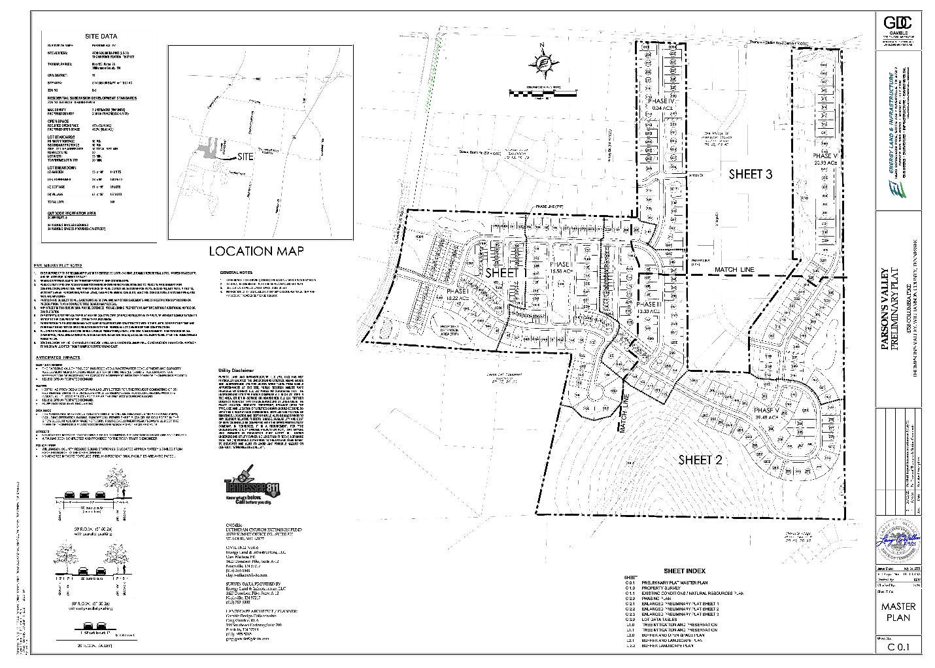

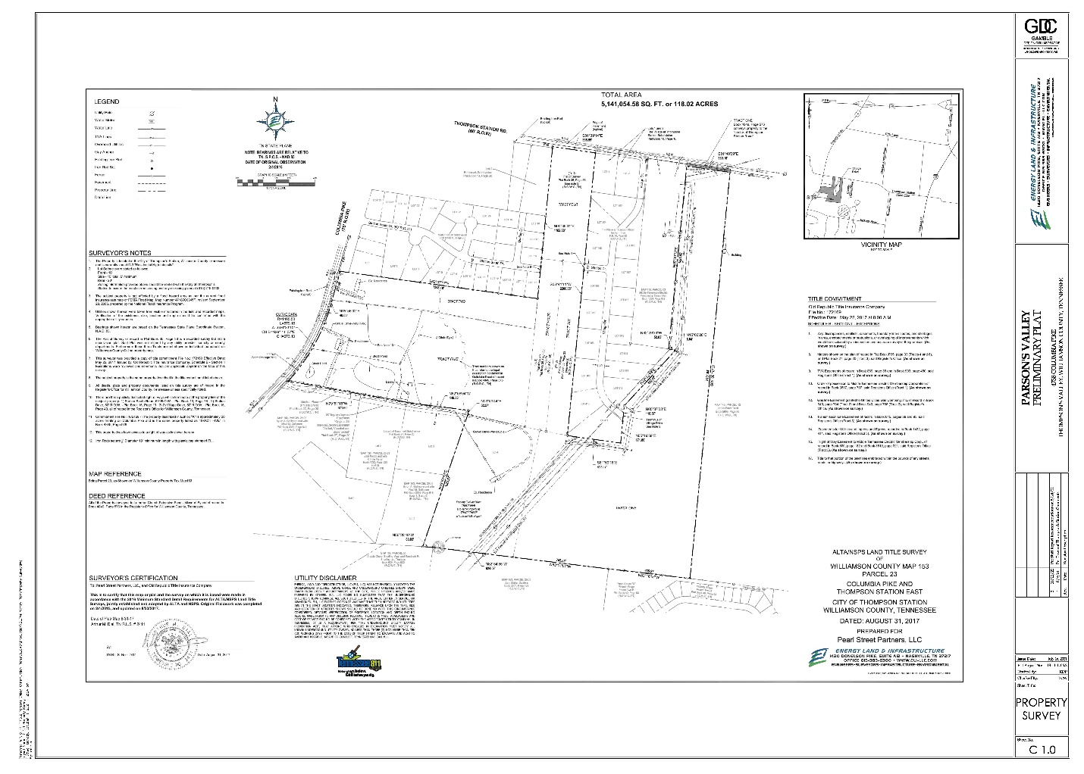
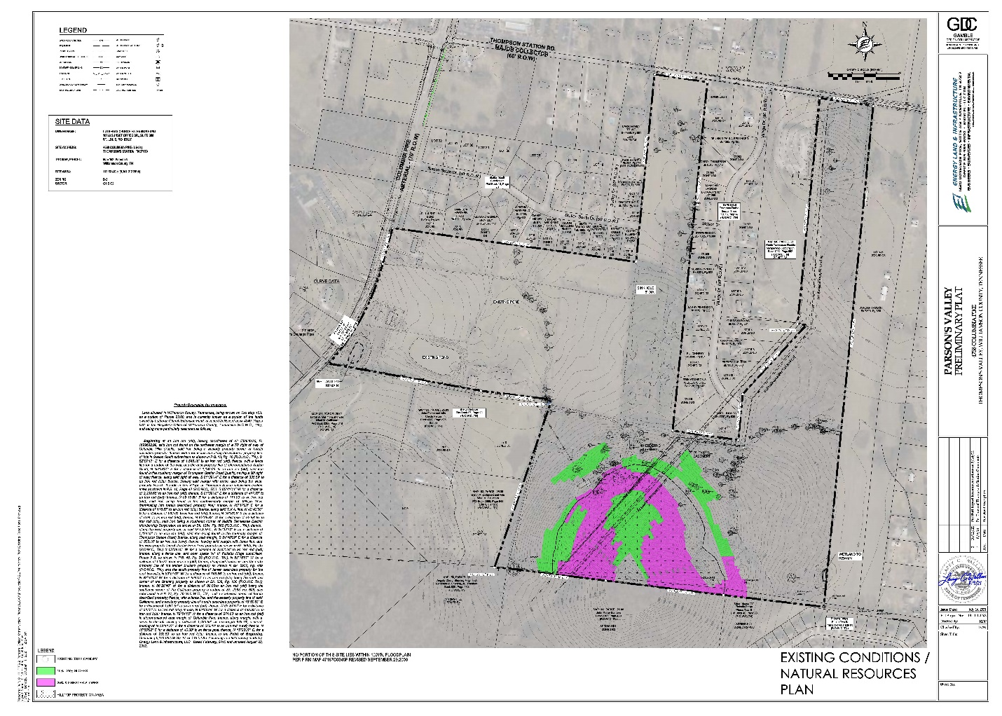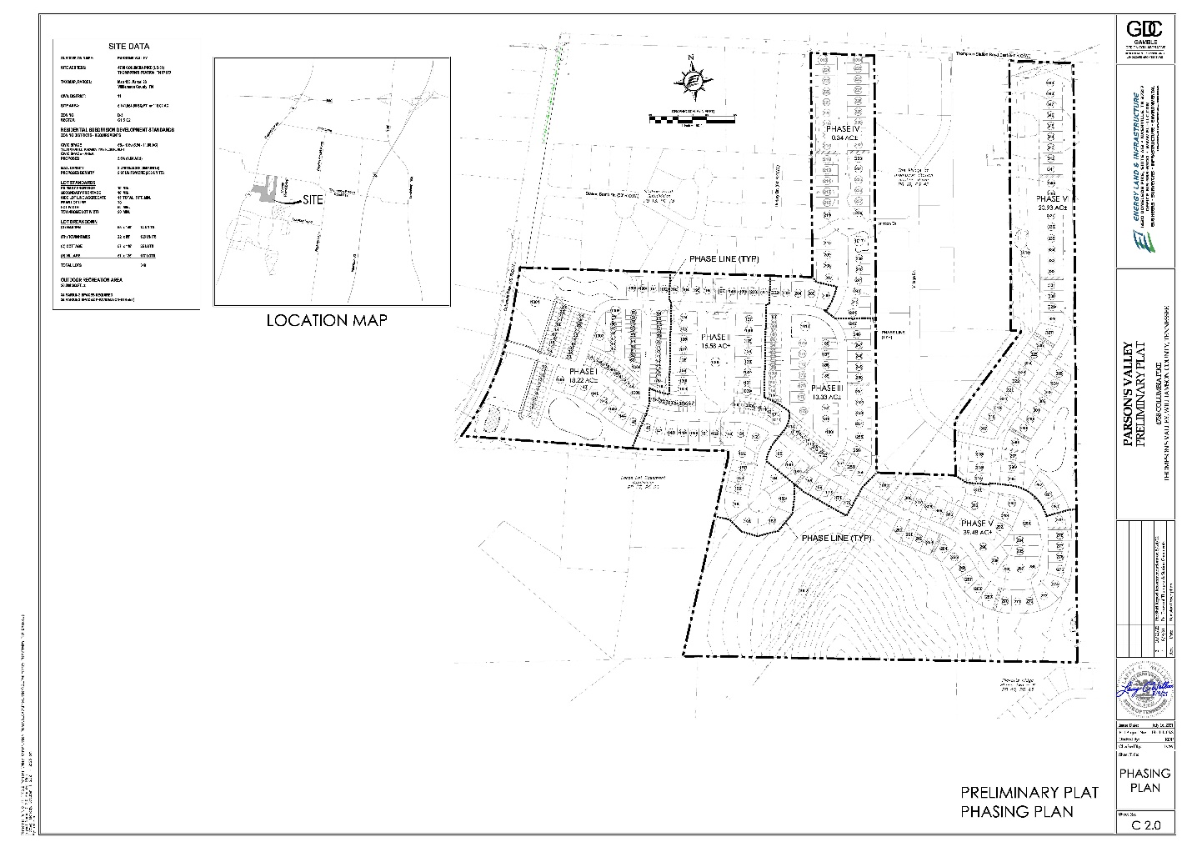
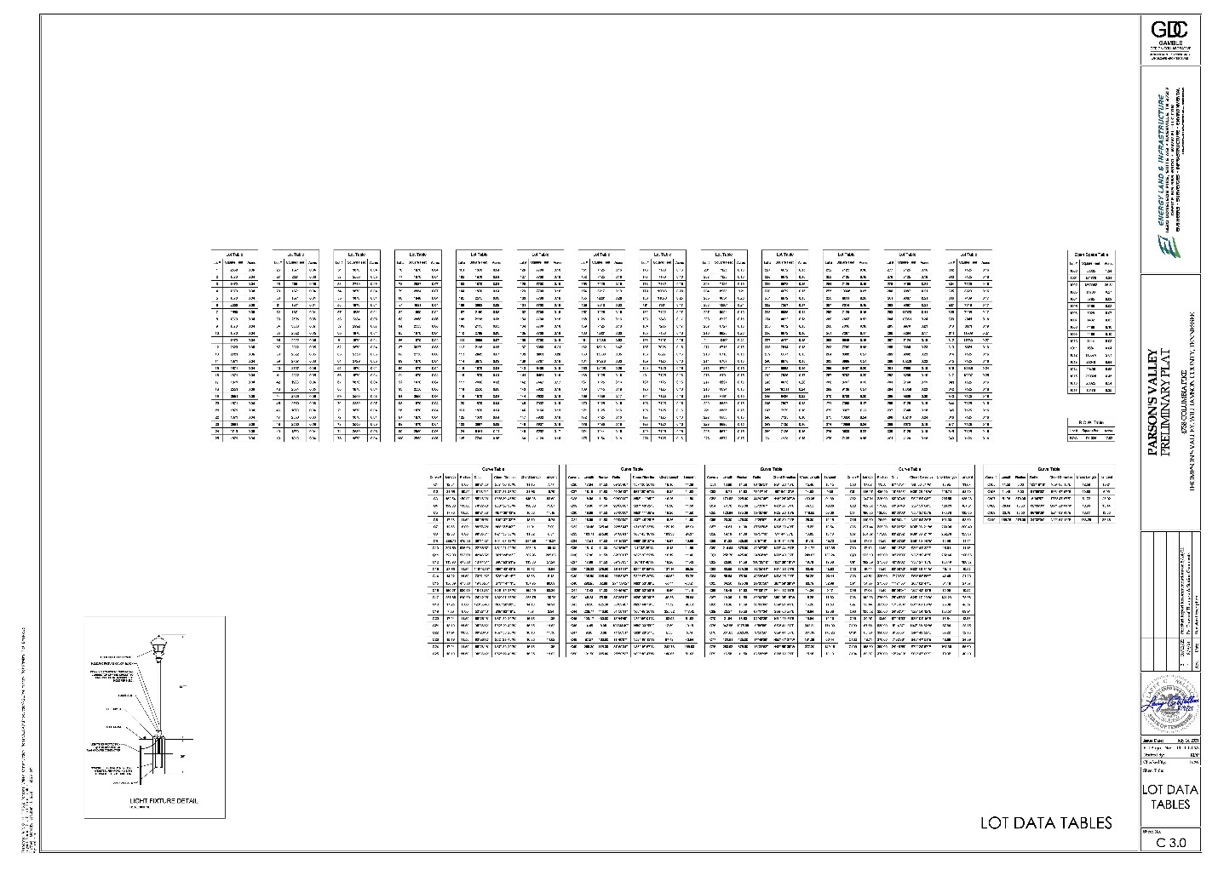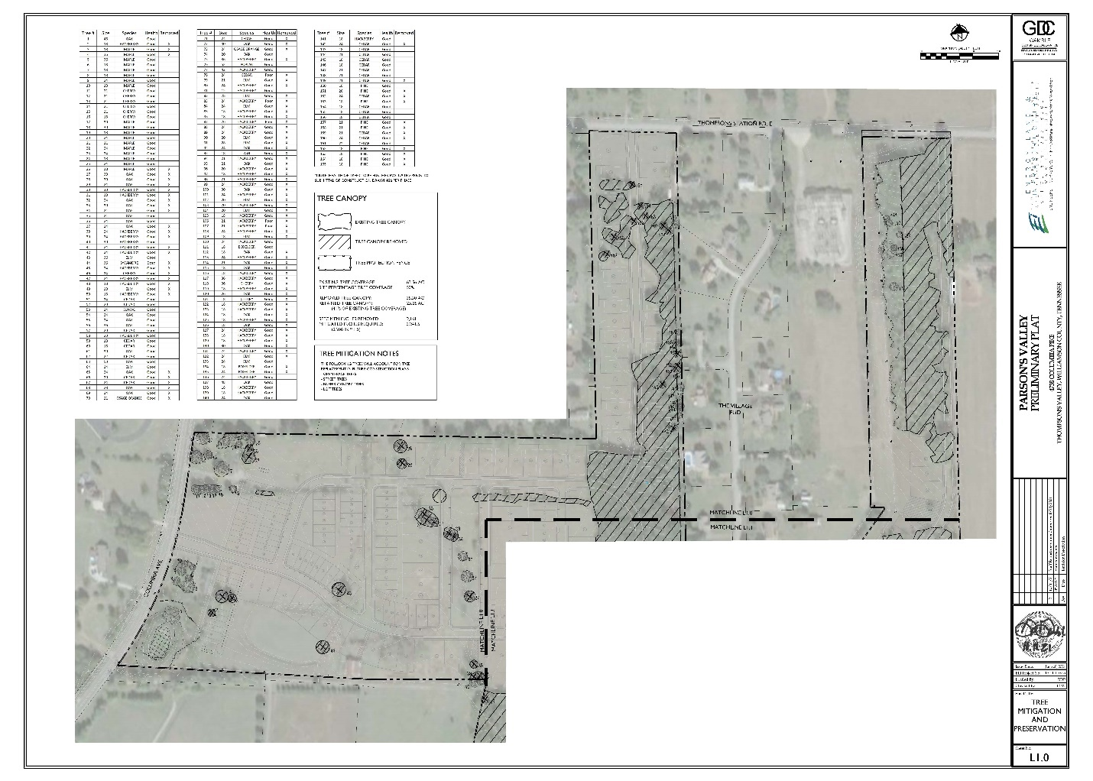
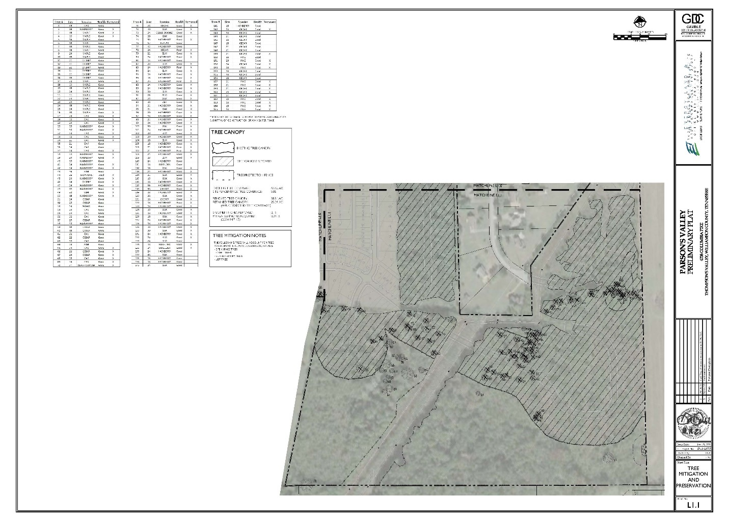
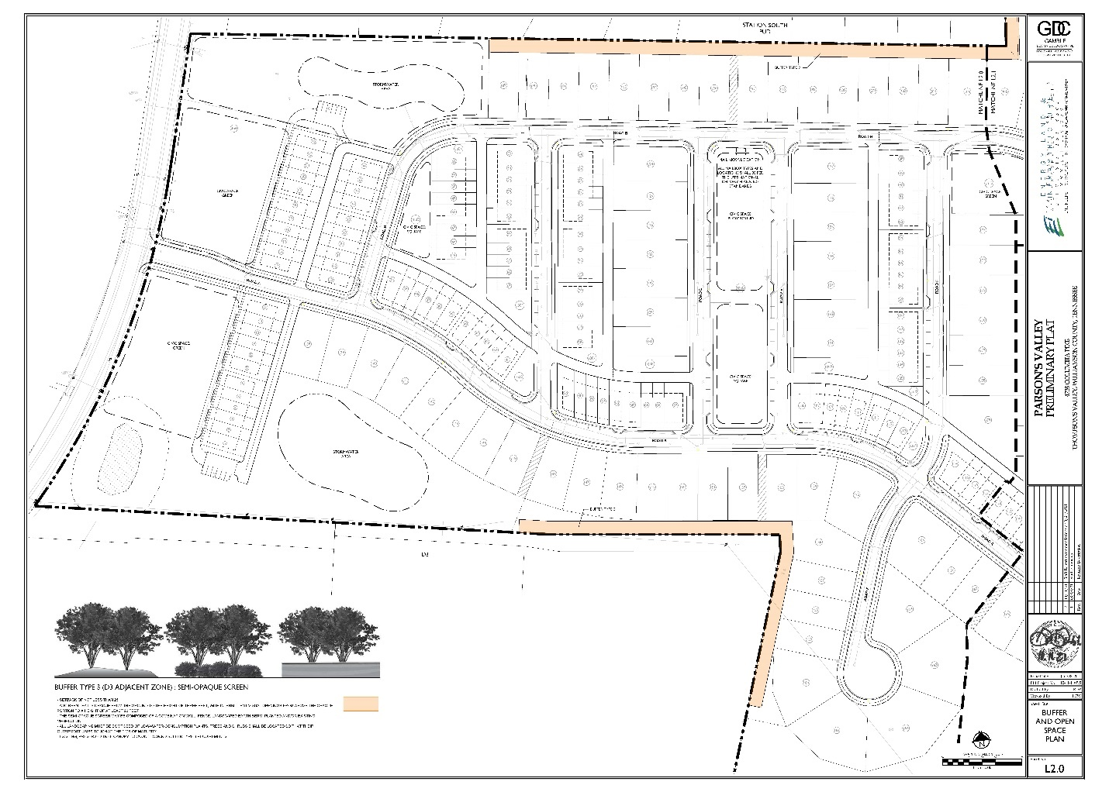

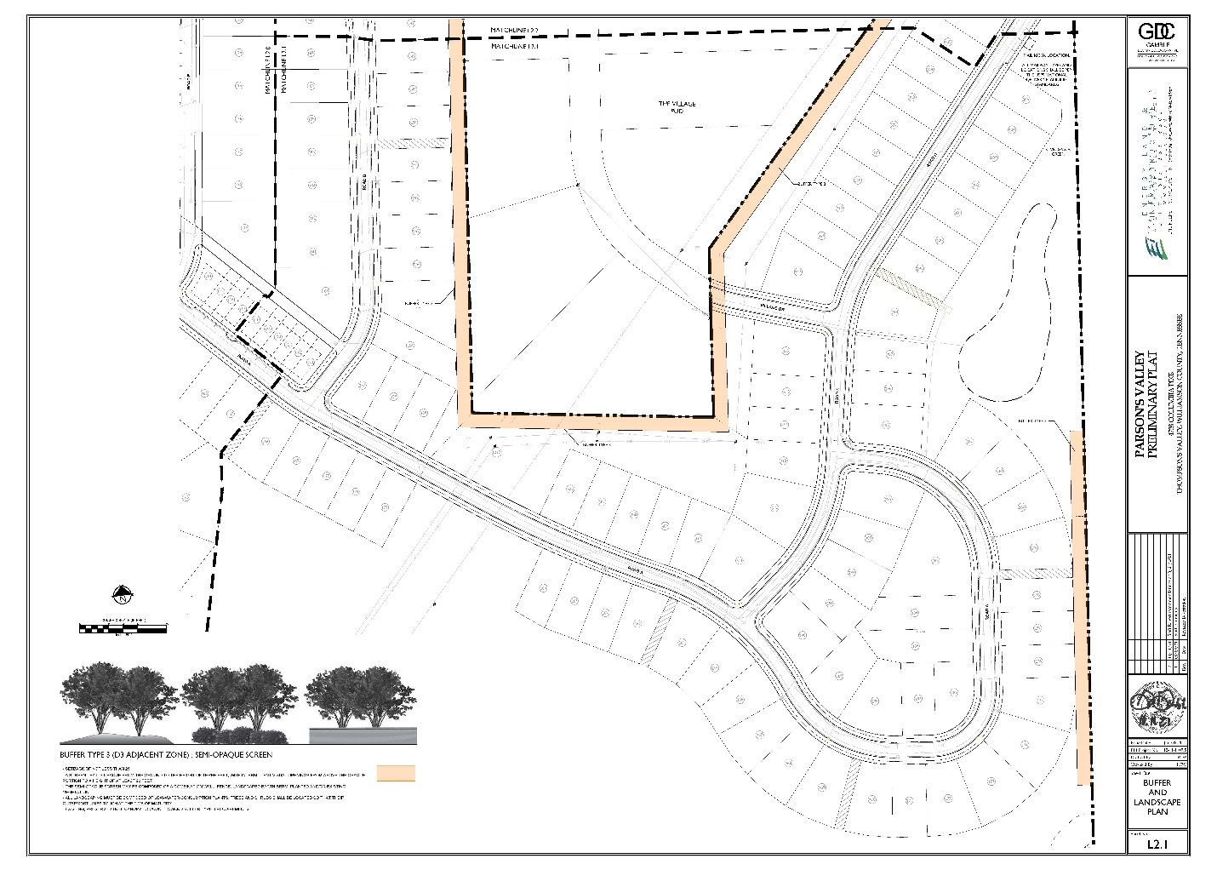
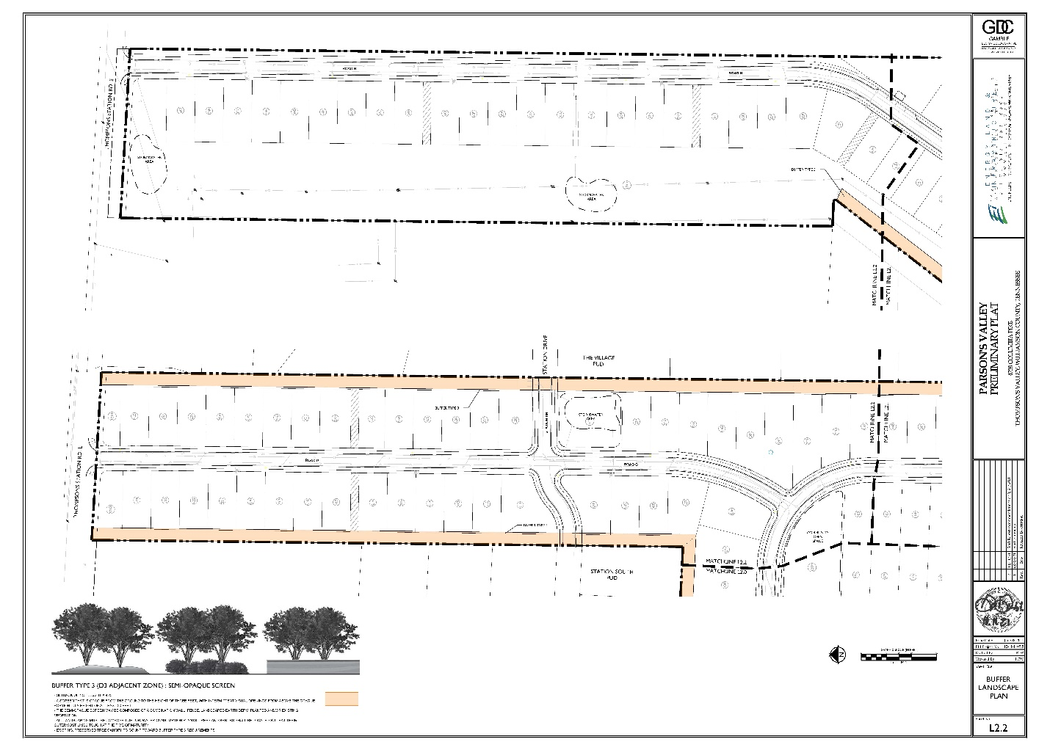

Exhibit “B”
Conditions of approval established by the Thompson’s Station Planning Commission (TSPC)

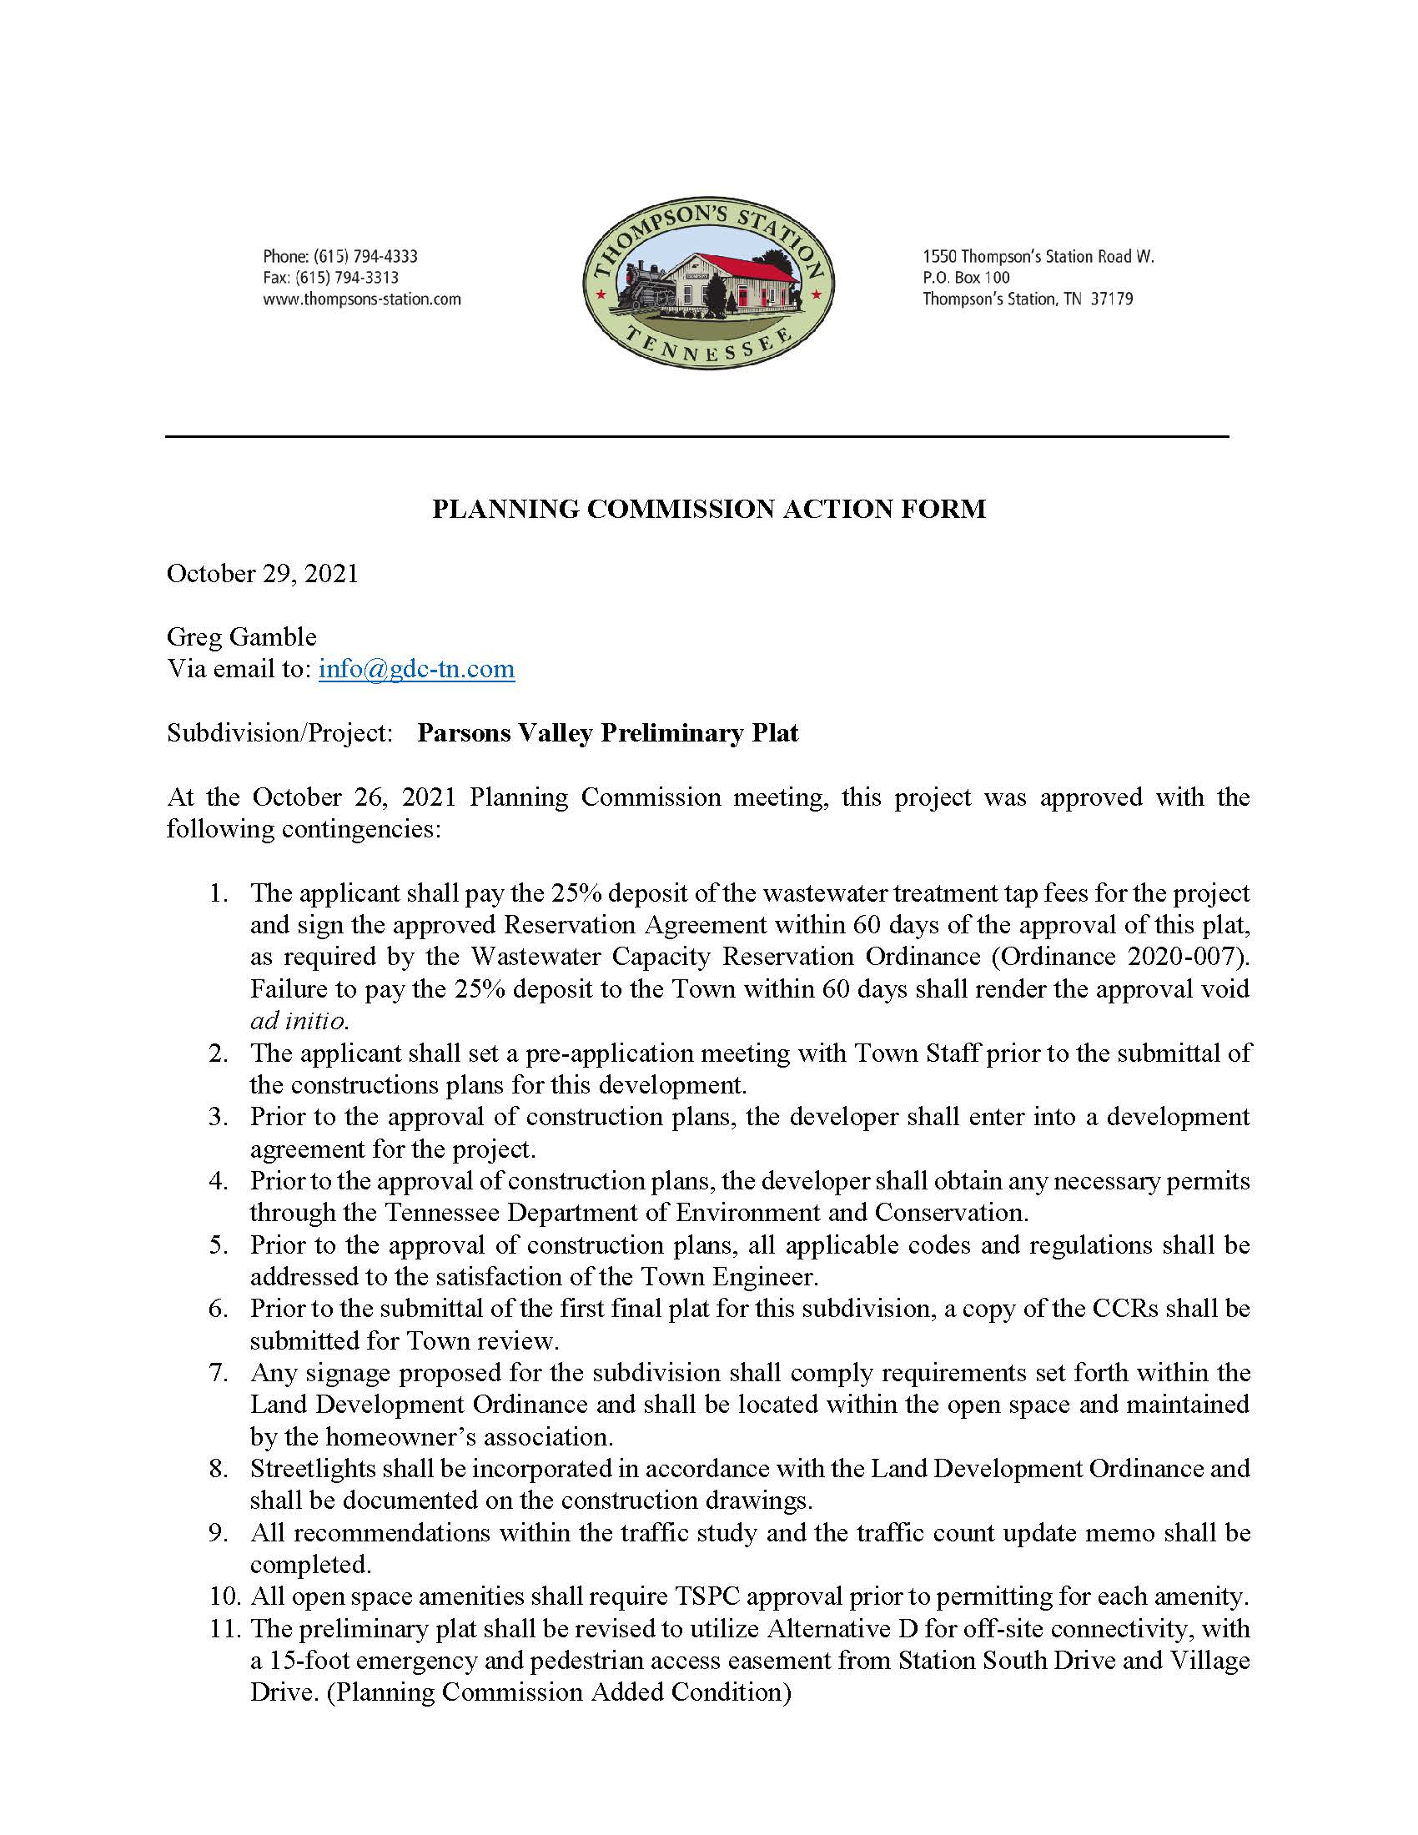

Exhibit “C”
Estimated Cost of Public Improvements:

Per the LDO and to be provided at the time of final plat approval by the Thompson’s Station Planning Commission.

Exhibit “D”
Performance and Maintenance Security Documents

Per the LDO and to be provided prior to signature on the Certification of Approval for Recording by the Secretary of the Thompson’s Station Planning Commission on each and every final plat submitted for this development.

